**Statistical Study on Increasing Usage of AR/VR in Real World**

**Abstract**

Augmented and Virtual Reality have emerged as powerful technologies to learn skills, revolutionizing the way people learn skills related to various fields. This study provides an overview of their impact on skill acquisition, how does it improve the process of learning a skill and what aspects make it different from traditional learning and its future prospects in this direction. In this research paper we explore how environments created by AR/VR facilitate experiential learning, improve motor skills and enhance a wide range of mental/cognitive processes. The implications of AR/VR technology for training programs, professional development, and educational setting are also studied and discussed.

**1. Introduction**

Augmented Reality (AR) and Virtual Reality (VR) are two great technologies that have evolved the way people interact with the digital world. AR is the technology to add digital elements to the real world around us, while VR is the technology to create immersive digital environments that may or may not replicate the real world in sense and form. Both technologies use special equipment such as headset or glasses to bring these experiences to life.

**AR**

Augmented reality (AR) can be considered as an enhanced version of the real world, achieved through the utilization of digital information and projecting to show in semblance with the real-world environment. At the core of it AR is used to add features to real world using computer generated digital information, whether the features are for utilization or display they all add new information to our interpretation of the real-world environment that elevates our experience towards the said environment. AR can be utilized through multiple senses including visual, auditory, touch etc. AR technology uses computer hardware and software for example apps, consoles, projections etc., to combine digital information with the real-world environment.

It is growing trend among companies developing metaverse implementations such as mobile computing and business applications, to use AR as in their implementation.

Various fields which have applications for AR include gaming, product visualization, marketing campaigns, architecture and home design, education etc.

**What is virtual reality?**

Virtual reality refers to a simulation of a 3D environment that allows users to explore and interact with the said virtual surroundings in a way that may or may not approximate reality, as perceived through the users’ senses. Whether or not the interaction with the 3D environment will approximate to reality would depend on the purpose of the creator of said virtual environment. The 3D environment is created using relevant computer hardware and software, while users need helmets and goggles to interact with the environment. The development of VR technology is aiming for a direction wherein the users would be immersed in the created environment in such a manner that the virtual surroundings would be indistinguishable from reality in all senses.

**Education and skill training**

Education has always been an important area of application for VR systems so that students could efficiently train for real life activities. The appeal of simulations was exactly that they can provide training that could stand equally with practice with real systems, adding the reduced cost and greater safety along with that made it tree worth growing for companies. This was particularly found in the case of military training, where the first significant commercial application of simulations was seen, it was pilot training simulators used in the 2nd World War. Such simulators relied on visual-motion feedback to augment the sensation of flying while the user is seated in a closed mechanical system placed on the ground.

An important area of application for VR systems has always been training for real-life activities. The appeal of simulations is that they can provide training equal or nearly equal to practice with real systems, but at reduced cost and with greater safety. This is particularly the case for military training, and the first significant application of commercial simulators was pilot training during World War II. Flight simulators rely on visual and motion feedback to augment the sensation of flying while seated in a closed mechanical system on the ground.

As highlighted above, AR/VR technology enhances the learning process of people in various domains and fields through simulations which may put people in various positions by simulating various situations or examples of situations, thereby enhancing experiential learning. This point can be further enunciated with examples of other fields as well, simulated surgical training and skill improvement is known to be one of the most revolutionary uses of AR/VR technology in the healthcare industry, in countries like Netherlands, and United kingdom the police departments is being trained using AR/VR technology to train them for various emergency scenarios, companies like Walmart have also implemented VR training programs to train employees in various departments etc.

**Increasing Usage and Adoption**

The global shipments of AR/VR headsets were 5.5 million units in 2020 and are projected to reach 43.5 million by 2025.The market size of VR headsets was $5.5 billion in 2019 and is projected to reach $18.6 billion by 2026.The global AR/VR software and hardware market size was valued at $2.6 billion in 2020, which will jump to $5.1 billion by 2023.[1]

- The AR market is projected to hit a value of $50 billion by 2024.

Industry Adoption:

- The strongest demand for AR/VR currently comes from industries in the creative economy—specifically, gaming, live events, video entertainment, and retail.

- AR/VR technologies have increasingly been employed by a wide range of sectors —from education and healthcare to retail and real estate.

- AR technology blends the physical and digital worlds - be it gaming or consumer goods, AR and VR help businesses provide a better experience to their customers.

Various applications and software for AR/VR which are widely popular include things like OSSOVR(a clinically validated surgical training and assessment platform designed for medical device companies and practicing surgeons of all skill levels), PokemonGo(a popular**augmented reality (AR)**mobilegamedevelopedby**Niantic**incollaborationwith**The Pokémon Company**and**Nintendo**.) for Gaming, Tilt Brush(is a powerful tool for creative expression in VR) for Painting, Enscape( a real-time rendering and visualization plugin for architectural software like **Revit**, **SketchUp**, and **Rhino**) for architectural design**, Hyundai Virtual Guide(** An AR smartphone application by Hyundai that owners can use to understand their vehicles better), **Toyota’s TeenDrive 365 (**Toyota employs simulation of driving environment to prove the aftermath of negligent driving with the help of their software) etc.

This Research paper will further explore and discuss such innovations, their degree of benefit and effectiveness, as well as further and upcoming implementations. This study will mainly employ existing literature, case studies and empirical research to elucidate the role of AR/VR technology in shaping the future of skill acquisition and lifelong learning.

**2. Examples, Implementations and Related Work**

|  |  |  |  |
| --- | --- | --- | --- |
| Reference | Subject | Method | Findings |
| Abdullah M. Al-Ansi | AR and VR development in Education | Analyzing | Adoption of AR and VR in education recent years |
| Dr A Udaya Shankar | Impact of AR and VR in Education | Literature Review | Improvement in teaching and learning experience |
| Patrice Labedan | VR in pilot training | Case Study | Cardiac activities during training |
| Zain Hussain | Use of AR and VR for improving knowledge and skills in medical students | Randomized Trials and Pre-test, Post-test | Effectiveness of AR/VR devices for teaching medical students |
| Min-Chai Hsieh | AR for primary marine wildlife education | ADDIE model with Pre and Post test | Using augmented reality to enhance learning experience of children for marine wildlife education |
| İbrahim Yaşar Kazu | Engagement of AR and VR in higher studies | Data Analysis | VR's adaptability and potential for personalized learning experiences contributing to more efficient and effective learning |
| Jing Zhang | Trends in the Use of Augmented Reality, Virtual Reality, and Mixed Reality in Surgical Research | Global Bibliometric and Visualized Analysis | [use of augmented reality (AR), virtual reality (VR), and mixed reality (MR) in surgical research](https://link.springer.com/article/10.1007/s12262-021-03243-w) increased globally |

**Al Ansi et al.** analysed the recent developments of AR and VR in education by studying various publication and graphing out the distribution of publications that talk about the implementation AR/VR for education in any of the various field. Their paper proved the dramatic increase in AR/VR research in the preceding decade, the exponential growth of AR/VR adoption in education during the covid-19 pandemic, how AR/VR enhances communication and interactions between students and teachers in e-learning. Similarly, **Dr A Udaya Shankar et al.** conducted a literature review on the impact of AR and VR in education, proving the strong relationship between AR/VR and its impact on education. The study what descriptive in nature, and used questionnaires as well. The findings showed an improvement in teaching and learning experiences. **Patrice et al.**  conducted a case study on VR in pilot training. Studying physiological parameters of pilots during stages of the flight in the simulator and comparing the data with real life to find how much the simulator worked in simulating flight situations and proposing possible improvement. **Zain et al.**  used randomized trials and pre-test, post-test methods to study the use of AR and VR for improving knowledge and skills in medical students. The findings showed the effectiveness of AR/VR devices for teaching medical students. **Min-Chai Hsieh** applied the ADDIE model and pre-test, post-test methods to study the use of AR for primary marine wildlife education. The findings concluded that using augmented reality enhances the learning experience of children for marine wildlife education. **İbrahim Yaşar Kazu** performed data analysis on the engagement of AR and VR in higher studies. The findings showed that VR’s adaptability and potential for personalized learning experiences contribute to more efficient and effective learning. Lastly, **Jing Zhang** conducted a global bibliometric and visualized analysis on trends in the use of augmented reality, virtual reality, and mixed reality in surgical research. The indicates a clear global increase in the use of augmented reality (AR), virtual reality (VR), and mixed reality (MR) in surgical research, with the USA leading in contributions and emerging trends suggesting a continued rise in the future.

The amalgamation of such studies shows not only the different areas in which implementations of AR/VR technology being developed but also that AR/VR is helpful and would be growing in usage in the future. Thus comes our hypotheses,

H1: The usage and implementation of AR/VR in various fields is still increasing.

H2: Developing implementations will have a majorly positive impact on the AR/VR technology field.

H3: Common use commercial implementations of AR/VR are becoming increasingly popular.

**3. Information Study**

**Hypothesis 1:**

**Education**: AR and VR technologies are transforming the education sector by making learning more immersive and engaging. They can improve learning for students with short attention spans, make lessons more engaging, and help them pick up new information quickly. Additionally, AR and VR in education can make the whole sector more inclusive by providing access to the same material for students with different learning styles.

According to the report from EducationVRMarket.com in their blog post ‘VR in Education: A 2024 Perspective’, the VR market in the education industry was valued at USD 25.85 billion in 2024 and is projected to reach USD 67.02 billion by 2029. Another report from TechAdoptionMonitor.com in their blog post ‘VR Usage in the US’ states that approximately 1 in 5 adults in the United States has experienced VR technology. For 64% of VR users, gaming remains the primary attraction.

**Healthcare**: AR and VR technologies are being adopted in the healthcare sector to foster a deeper understanding of complex concepts, ignite student curiosity, and promote collaborative learning. They are used in medical education, diagnostics, surgery, and fitness.

According to a report from HealthTechARVR.com in their blog post ‘AR & VR in Healthcare: A 2022 Overview’, the global Augmented Reality & Virtual Reality in healthcare market size was valued at USD 2.5 billion in 2022 and is expected to expand at a compound annual growth rate (CAGR) of 18.8% from 2023 to 2030.

**Gaming:** AR and VR have revolutionized the gaming industry, ushering in an era of immersive experiences. They have seen the most success in the entertainment sector, particularly in the video game industry. Games like Pokémon GO and devices such as the Oculus Quest 2 and PlayStation VR have had widespread adoption.

According to a report from GamingStats.com in their blog post ‘AR & VR Gaming in the US: A 2023 Perspective’, as of 2023, there are 65.9 million VR users and 110.1 million AR users in the U.S. Gaming is the most favoured application of AR, with approximately one-third (32%) of Americans interested in playing AR video games.

**Automobile Industries**: AR and VR technologies are transforming the automotive industry by enhancing customer experiences and gaining a competitive edge. They are being used for design, production, sales, and even marketing.

According to a report from AutoTechReview.com in their blog post ‘VR in Automotive: A 2027 Forecast’, the global virtual reality in automotive market size was valued at USD 759.3 million in 2019 and is projected to reach USD 14,727.9 million by 2027, exhibiting a CAGR of 45.1% during the forecast period.

**Engineering**: AR and VR technologies are being adopted in the engineering sector to enhance comprehension of intricate processes. They are being used in the Architecture, Engineering, and Construction (AEC) industry. However, the AEC industry, relative to other industries, has been slow in adopting AR/VR technologies, partly due to lack of feasibility studies examining the actual cost of implementation versus an increase in profit.

According to a report from ManufacturingTechTrends.com in their blog post ‘VR in Manufacturing: A Three-Year Outlook’, 53% of manufacturing companies say VR will become mainstream in their organization within the next three years. The AR & VR market in India is expected to have approximately 742.3m users by 2028 according to another report from IndiaTechReview.com in their blog post ‘AR & VR in India: A 2028 Forecast’.

**Military**: AR and VR technologies are transforming the military sector by offering innovative ways to engage and entertain audiences. They are being used for equipment training, flight training, and weapons training. The combination of AR and VR, often called extended reality (XR), has huge potential to transform digital technology in the defense sector and revolutionize the way armed forces personnel access information, plan mission strategy, and conduct critical operations.

According to a report from MilitaryTechNews.com in their blog post ‘Digital Training in the US Military’, the US Defence Department spends around $14 billion annually on synthetic digital training, which amounts to 2% of the total US military spending in a year.

**Manufacturing**: AR and VR technologies are transforming the manufacturing sector by offering innovative ways to engage and entertain audiences. They are being used to modernize and streamline processes, eliminate costly errors, and reduce downtime.

According to a report from ManufacturingTechTrends.com in their blog post ‘AR & VR in Manufacturing: A 2030 Forecast’, the global augmented reality & virtual reality in manufacturing market size was valued at USD 8.01 billion in 2022 and is expected to grow at a compound annual growth rate (CAGR) of 28.3% from 2023 to 2030.

**Entertainment**: AR and VR technologies are transforming the retail sector by enhancing customer experiences and gaining a competitive edge. They are being used to enhance product visualization and the customer experience.

According to a report from EntertainmentTechReview.com in their blog post ‘AR & VR in Entertainment: A User Perspective’, social media content is seen as the medium with the highest VR/AR usage rate at 47%, followed by videogames (40%), live streaming (32%), film and entertainment (31%), advertising (28%), and music (28%).

The increasing market size throughout the years as shown in the chart as well as the previous explained statistics for various fields represent the fact that the usage and implementation for AR/VR in various fields globally is increasing throughout the years thereby suggesting that H1 is true.

**Hypothesis 2:**

**1. Spatial computing:** It refers to technology that would allow computers to better understand and interact with the physical world, enabling AR/VR application to accurately map and overlay content onto the user’s environment.

Benefits: Spatial computing boost user immersion through its seamless integration of virtual content, it enables better intuitiveness of interactions and opens up further possibilities for enhancing productivity, visualization, gaming, education etc.

**2. Immersive Commerce Platforms:** This implementation involves leveraging AR/VR technology to transform the way consumer buy and interact with products online. Such platforms would allow things like virtual try-ons, interactive product visualization etc.

Benefits: Immersive Commerce platforms would enhance the online shopping experience, providing users with a more realistic and immersive preview of products, helping them in making purchase decisions. With the enhanced customization things like customer engagement and conversion rates would also increase.

**3. Emotion Recognition:** This technology would work using biometric sensors and machine learning algorithms to analyze the users’ expressions, gestures and other physiological responses, such systems would raise emotional engagement and personalization in VR experiences.

Benefits: Emotion recognition in VR would allow empathetic and adaptive experiences by dynamically adjusting content based on the emotional state of its users. Things like communication, therapy and training applications would experience enhancement in online medium because of the provided real time feedback on emotional responses.

**4. Haptic Feedback Technologies:** This technology aims to simulate tactility in various sensation like vibrations, force, texture etc., for AR/VR environments.

Benefits: Haptic feedback technology would enhance the usage experience in AR/VR by adding the various senses of daily life into the virtual world thereby allowing users feel things like sense of touch, smell etc. Allowing users to feel and interact with virtual objects more realistically would improve things like simulations, gaming experience, medical applications etc.

**5. 6 Degrees of Freedom Tracking:** This technology allows users to move freely in the physical space while simultaneously tracking their movements in the six degrees of freedom accurately. (6DOS – forward/backward, up/down, left/right, roll, pitch, yaw).

Benefits: 6DOS enhances the immersion and realism in the VR experience by allowing users to explore virtual environments with natural movements. The accurate enabling of such movements improves user comfort, reduces motion sickness and widens the range of interactive applications that can be supported.

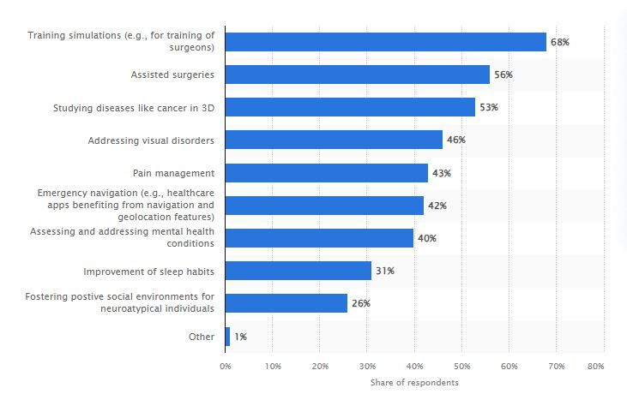

**7. AR/VR in healthcare:** Augmented Reality (AR) and Virtual Reality (VR) are revolutionizing healthcare, with their applications spanning across various departments within hospitals. The most significant use case is in training simulations, particularly for surgeons, with 68% of respondents utilizing these technologies. This allows for a realistic, risk-free environment for practice, enhancing the training process. Assisted surgeries, another major application area, leverage AR and VR to improve surgical precision and outcomes, with 56% of respondents indicating its use. Studying diseases like cancer in 3D is another critical application, with 53% of respondents utilizing AR and VR for this purpose, leading to a better understanding of the disease and improved treatment strategies.

AR and VR are also being used to address visual disorders (46%) and manage pain (43%), showcasing their versatility in patient care and treatment. Emergency navigation features facilitated by geolocation are utilized by 42% of respondents, proving particularly useful in emergency situations. Assessing and addressing mental health conditions accounts for a 40% share, with AR and VR providing immersive therapies and aiding in monitoring patient progress. Improvement of sleep habits (31%) and fostering positive social environments for neuroatypical individuals (26%) are other areas where these technologies are being applied. These statistics highlight the transformative potential of AR and VR in healthcare, promising a future where these technologies are integral to patient care and treatment.

The previously mentioned applications/implementations of AR/VR and many more such implementation indicate the positive impact that such implementations will have in development of AR/VR as well as information science and even commerce. Thereby proving H2 to be right.

**Hypothesis 3:**

|  |  |  |  |  |  |
| --- | --- | --- | --- | --- | --- |
|  | Apple ARkit | Google ARcore | Meta quest | HTC Vive | Sony Playstation |
| Launched date | 5 June 2017 | 1 March 2018 | 21 May 2019 | 5 April 2016 | 13 October 2016 |
| Developed by | Apple Inc. | Google | Meta platforms | HTC corporation | Sony Group |
| Based on | AR(augmented reality) | AR(augmented reality) | VR( Virtual Reality) | VR( Virtual Reality) | VR( Virtual Reality) |
| Features | * device motion tracking * world tracking * scene understanding * display conveniences | * Motion tracking. * Environmental understanding. * Depth understanding. * Light estimation. * User interaction. * Oriented points. * Anchors and trackable. * Augmented Images. | * Boundary, Pass-through and Spatial Anchors * Voice commands and voice dictation * Display settings * Accessibility features | * Eye tracking * Motion Tracking * Audio Strap * Wireless Adapter * Facial Tracker | * 5.7 inch OLED panel * 1080p resolution * Social Video screen enabled * 3D audio effect * 360 degree head movement |
| Usage Area | IOS Mobile Applications like IKEA place, MeasureKIt, jigshaw, kings of pool etc. | Android applications like Measureapp, INKHUNTER, Mole Catch AR, Beer Pong etc. | Gaming, Entertainment, Fitness and Wellness, Travel, Design and playing virtually with friends | Gaming, Education and business sector | Entertainment and gaming |
| Market Revenue | 50.37 billion in 2023 | No data available | 1.9 billion in 2023 | 3 million | 25.96 billion |
| No. of Units Sold | Not applicable | Not applicable | 2.03 million | 1 million | 50 million |

The previously studied data well indicates how AR/VR is being used in day-to-day life and how its reach and sales is increasing thereby signifying the increasing popularity of AR/VR commercial products worldwide, proving H3 to be true.

**4. Apple Vision Pro Discussion and Future Scope**

**Apple Vison Pro**

The Apple Vision Pro is currently setting a new trend in the AR and VR industry. It has become a viral sensation, with users taking the device out into the world and sharing their experiences on social media. People have been seen wearing the headset while running errands, working out, and even driving.

The device can transform any room into your personal theatre, expanding your movies, shows, and games to your perfect size and experience them in Spatial Audio. It also features Apple’s first 3D camera, enabling you to capture magical spatial photos and spatial videos in 3D. The device’s interface, which relies on tracking your eye and hand movements to navigate, is being hailed as a revolution in AR/VR interfaces. It has been described as a generational leap in mixed reality interface design.

Despite its high price tag and lower battery life, the Vision Pro has seen a pre-order boom, with up to 180,000 units sold during the pre-order weekend. This shows that there is a significant demand for high-quality AR/VR devices, and Apple is leading the way in meeting this demand. The return rate has also dropped to just 1%, suggesting that those buying the product today have a good idea of what they are buying and why.

The future scope of Apple Vision Pro is immense. As AR and VR technologies continue to evolve, the device is expected to offer even more immersive and intuitive experiences. It could revolutionize various sectors, including education, healthcare, entertainment, and more, by providing more interactive and engaging ways to learn, work, and play.

**Future Scope:**

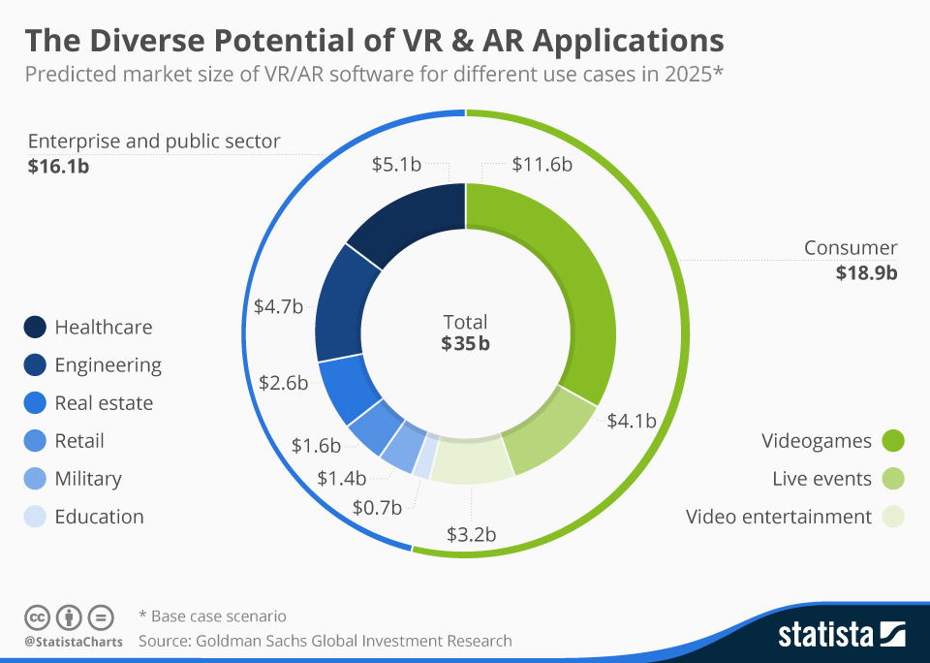

The graph titled “The Diverse Potential of VR & AR Applications” provides predictions for the market size of Virtual Reality (VR) and Augmented Reality (AR) software across different sectors in 2025. The total predicted market size is $35 billion, divided into the Enterprise and Public Sector ($16.1 billion) and the Consumer sector ($18.9 billion). The Enterprise and Public Sector is further broken down into Healthcare ($5.1 billion), Engineering ($4.7 billion), Real Estate ($2.6 billion), Retail ($1.6 billion), Military ($1.4 billion), and Education ($0.7 billion).

In the Consumer sector, the market is segmented into Videogames ($11.6 billion), Live Events ($4 billion), and Video Entertainment ($3 billion). The graph highlights the diverse potential of VR and AR applications, with healthcare and video games predicted to have the largest shares in their respective sectors. These predictions, sourced from Goldman Sachs Global Investment Research, represent a base case scenario, indicating that actual outcomes could be higher or lower depending on various factors.

**5. Conclusion**

The Usage and implementation of AR/VR is projected to keep increasing with the same boom as more implementations are added so will sales and market size of AR/VR will increase. This increase in implementations will bring positive impacts to user, companies, the field AR/VR. With the increasing performance from implementations, more convenient and well implemented devices will come to the commercial AR/VR products market, it’s a given these products will do well in said market. It is noted, that all three hypotheses converge and affect each other with various points of connection.